Name: Manaloto, Johnzelle Q.

Block: Wd - 301

[server.js](http://server.js)

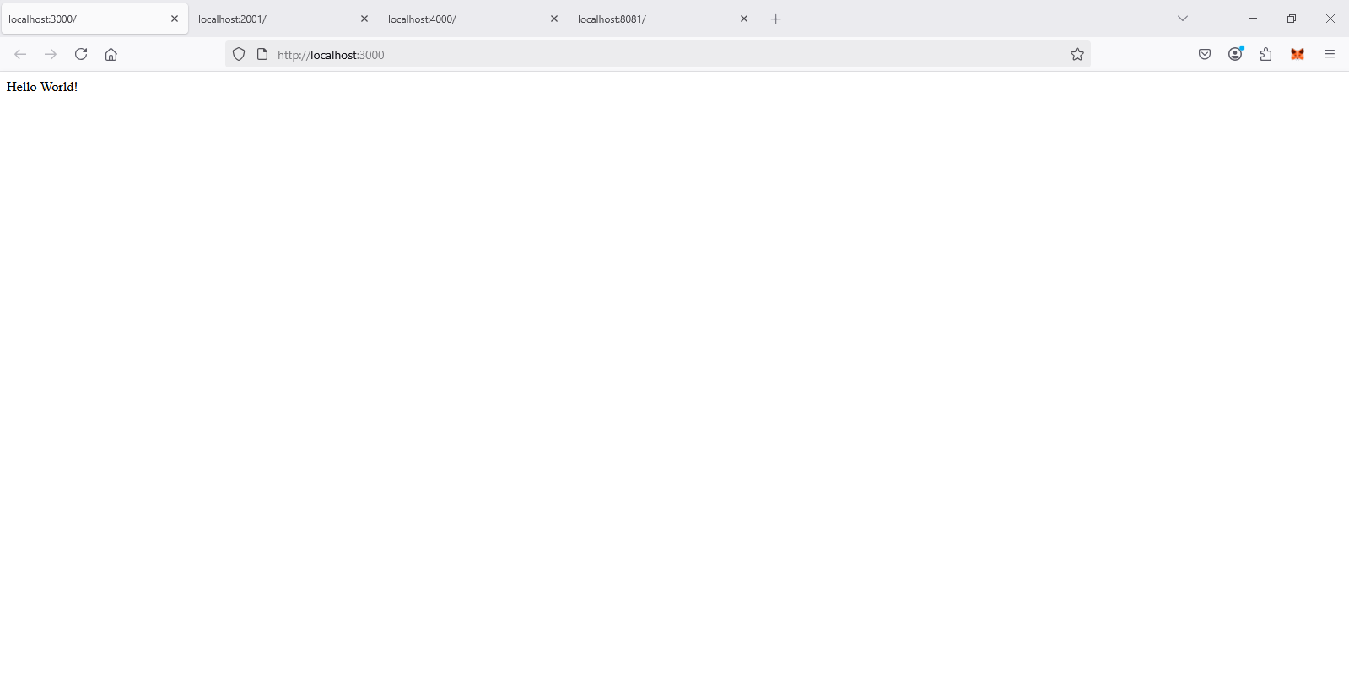

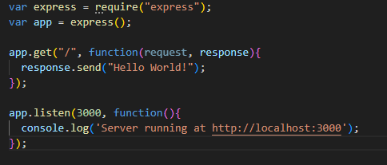

This simple server shows the basic structure of an Express application from requiring the framework to listening on a port. It has a simple initial "Hello World" route which is an important first step in web development.

[server2.js](http://server2.js)

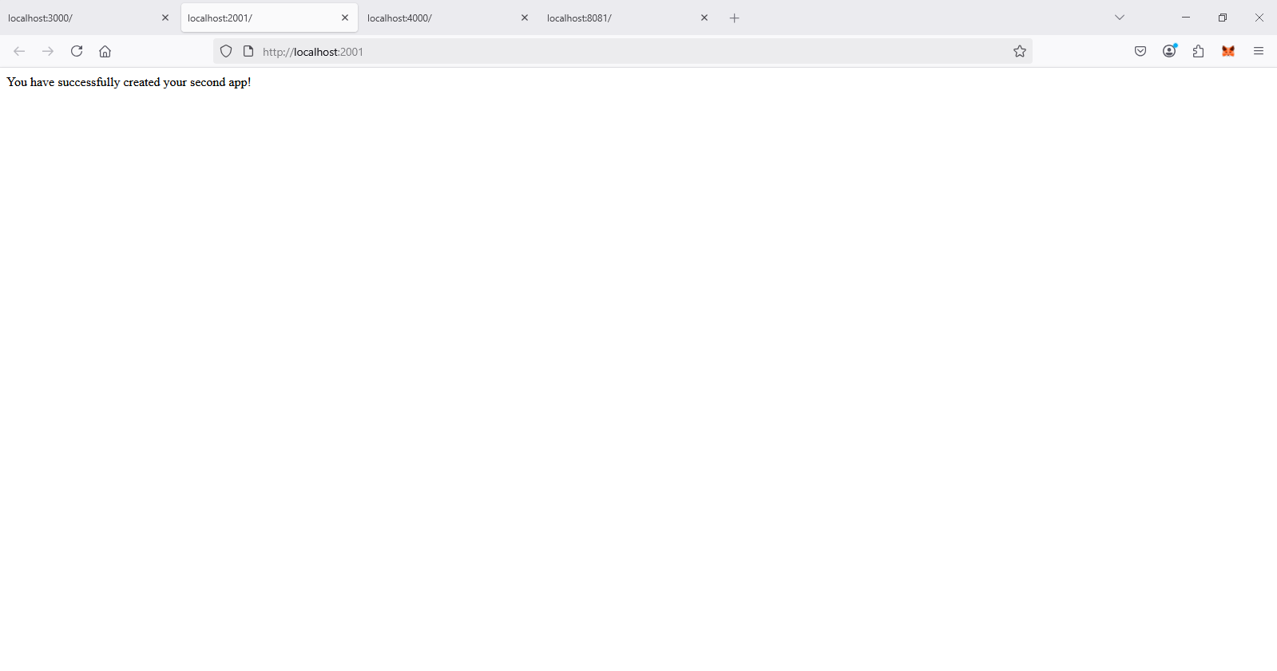

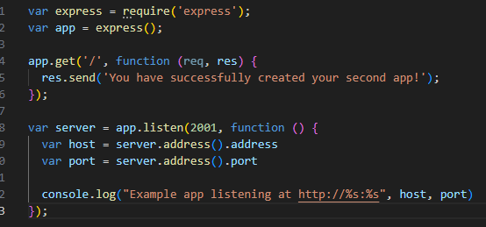

This code snippet expands on the previous example by providing a slightly more dynamic way of accessing the server address and port. It illustrates how to access properties of the server, and is good for log and verification purposes.

[server3.js](http://server3.js)

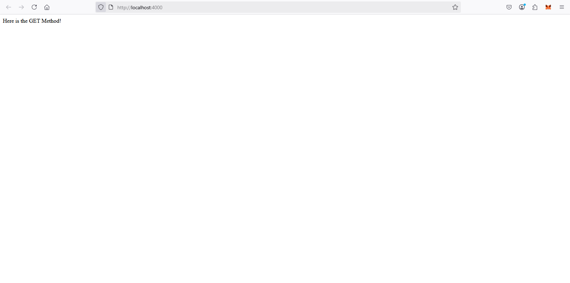

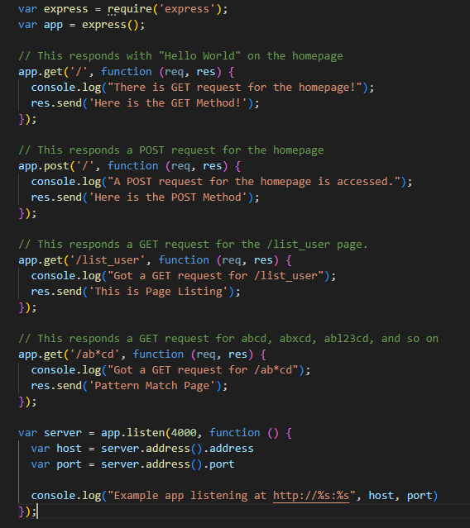

This code shows a very big difference, and it displays multiple HTTP methods (GET and POST), as well as the use of routing. The wildcard /ab*cd route also shows how express has powerful matching ability.

server_static.js

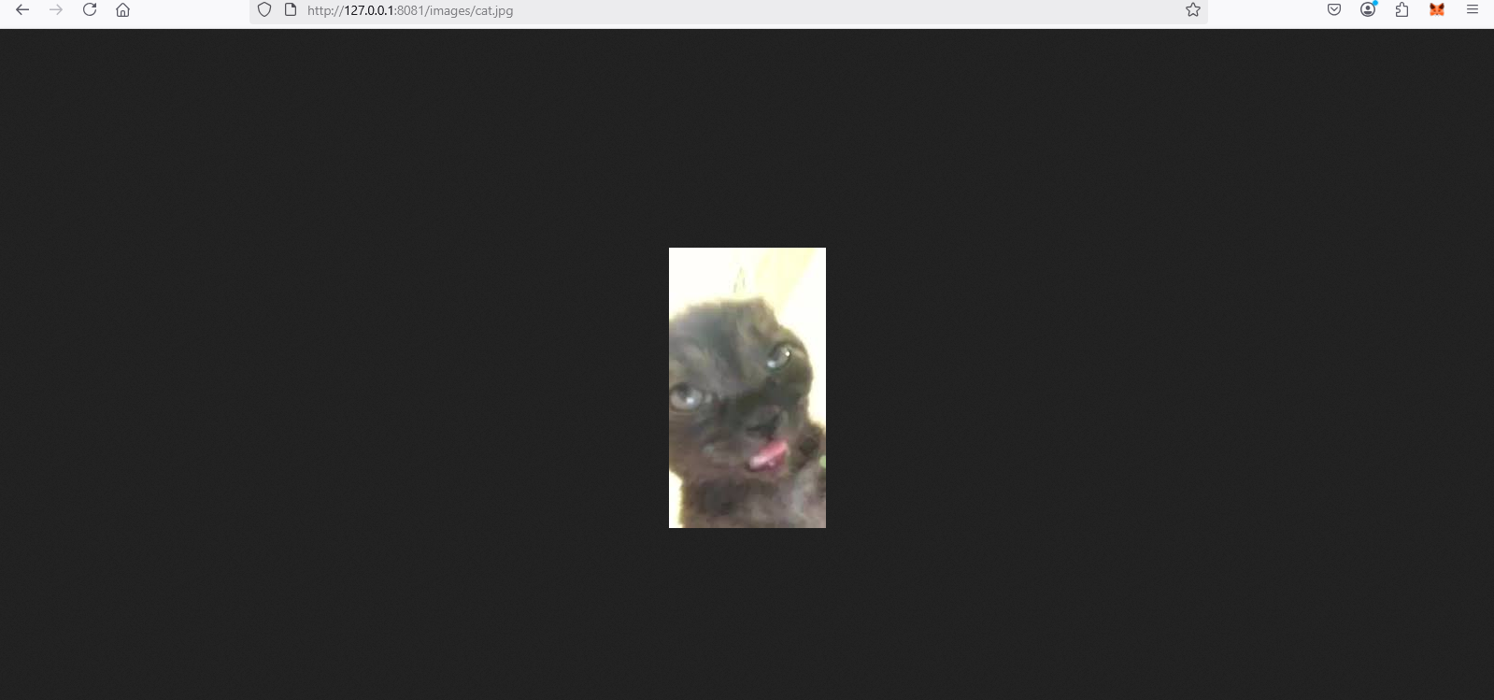

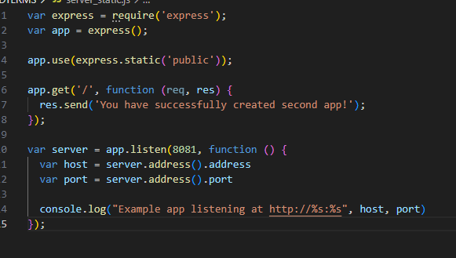

This example takes the next step by including middleware and serving static files from a "public" directory with express.static. This is a key step toward developing a real-world application on the web, because most web applications require the delivery of assets such as CSS, JavaScript, and images.